
Spatial 1-back Task Instructions
User hand: R

The goal of this task is to remember the location of a white square within a 3x3 grid. In the task, you will see a sequence of locations presented one after another:
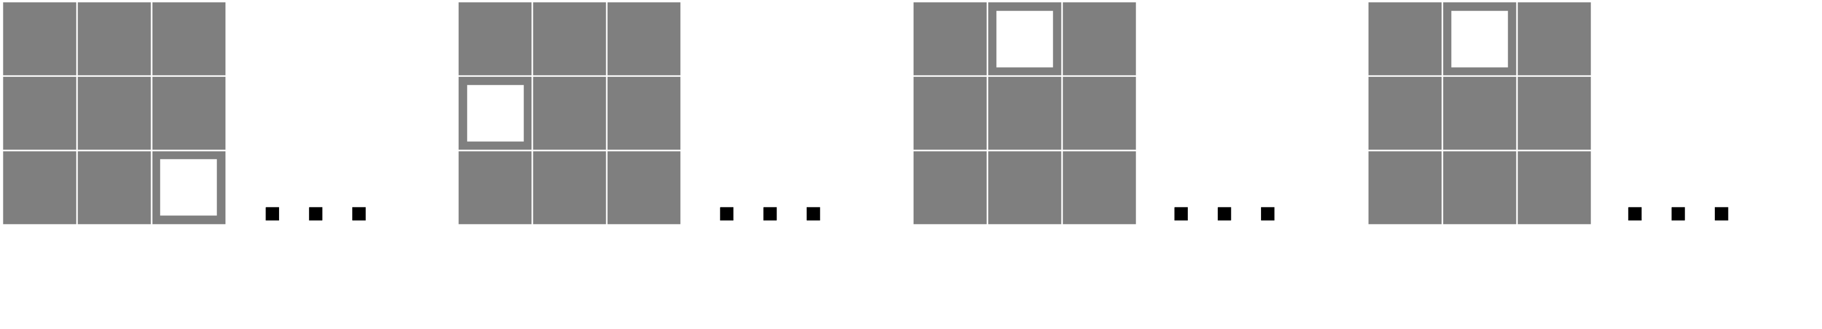
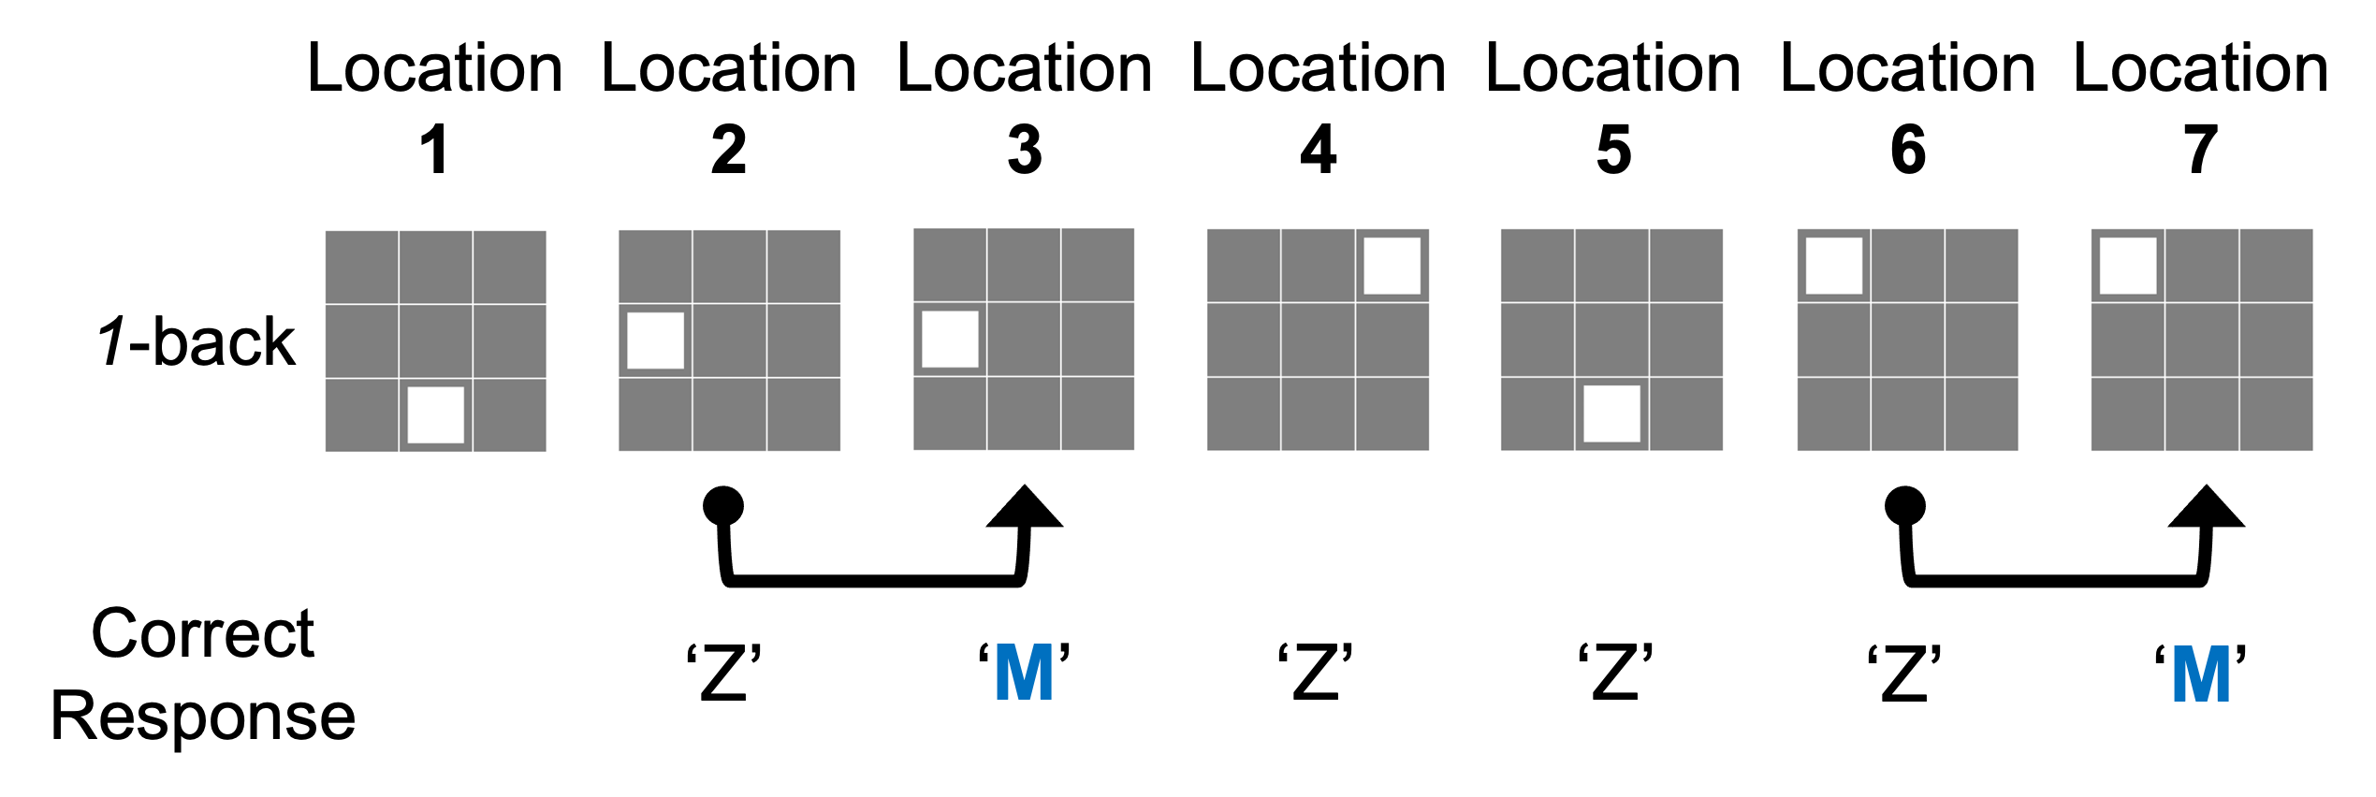
Your goal is to determine whether the location of the current square is the same or different from the one presented just before. Press the ‘M’ key whenever the current location is the same as the one presented just before. Otherwise, press the ‘Z’ key:

- In the above example, there is no response needed for location 1 as there was no previous location to compare to
- Location 2 is different to location 1, so a ‘Z’ [for different] response is correct
- Location 3 is the same as location 2, so a ‘M’ [for same] response is correct

Task protocol

After a 5 second countdown the first location will be presented. The second location will be presented shortly afterwards, and you will have to respond with the ‘M’ or ‘Z’ keyboard key. Take your time (up to 20 seconds per location shown) as only accuracy is important in this task. If you are unsure, please still respond using your best judgement.

For the duration of the task please place the index finger of each hand on the ‘M’ and ‘Z’ keys respectively.

There is 1 ‘block’ of 45 ‘trials’, in other words one sequence of 45 locations.

If you have any questions, please ask the experimenter now


2-back
User hand: R

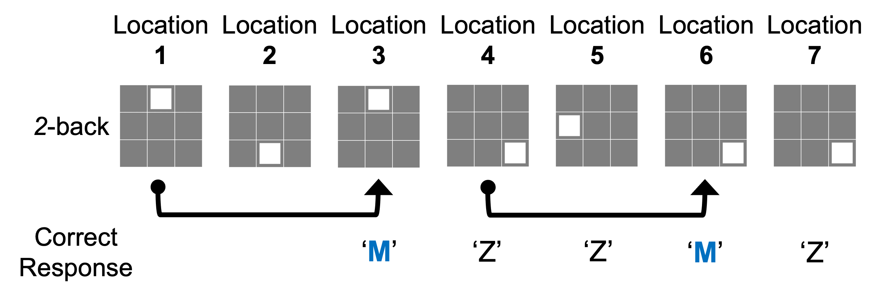
The goal of the second part of the task is to identify if the current location is the same as the location presented one before last (i.e., 2 positions back in the sequence):

- In the above example, there is no response needed for location 1 or 2
- Location 3 is the same as location 1, so a ‘M’ [for same] response is correct
- Location 7 is the same as location 6, but not location 5, so a ‘Z’ response [for different] is correct

If you have any questions, please ask the experimenter now

3-back

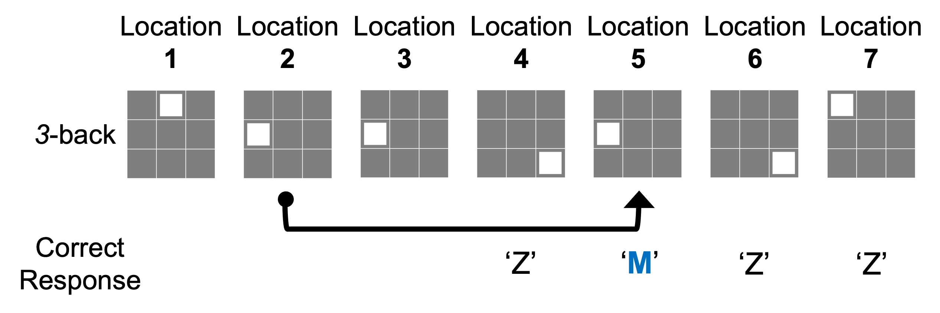
The goal of the third part of the task is to identify if the current location is the same as the location presented 3 positions back in the sequence:

- In the above example, there is no response needed for location 1, 2, or 3
- Location 5 is the same as location 2, so a ‘M’ [for same] response is correct

If you have any questions, please ask the experimenter now


Spatial 1-back Task Instructions
User hand: L

The goal of this task is to remember the location of a white square within a 3x3 grid. In the task, you will see a sequence of locations presented one after another:

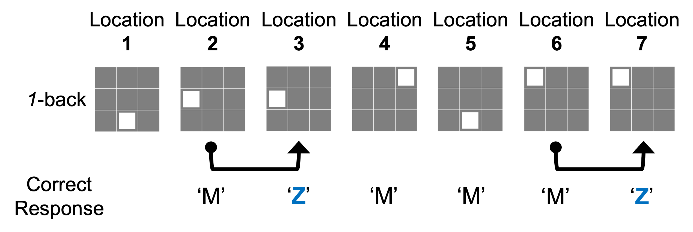
Your goal is to determine whether the location of the current square is the same or different from the one presented just before. Press the ‘Z’ key whenever the current location is the same as the one presented just before. Otherwise, press the ‘M’ key:

- In the above example, there is no response needed for location 1 as there was no previous location to compare to
- Location 2 is different to location 1, so a ‘M’ [for different] response is correct
- Location 3 is the same as location 2, so a ‘Z’ [for same] response is correct

Task protocol

After a 5 second countdown the first location will be presented. The second location will be presented shortly afterwards, and you will have to respond with the ‘Z’ or ‘M’ keyboard key. Take your time (up to 20 seconds per location shown) as only accuracy is important in this task. If you are unsure, please still respond using your best judgement.

For the duration of the task please place the index finger of each hand on the ‘Z’ and ‘M’ keys respectively.

There is 1 ‘block’ of 45 ‘trials’, in other words one sequence of 45 locations.

If you have any questions, please ask the experimenter now


2-back
User hand: L

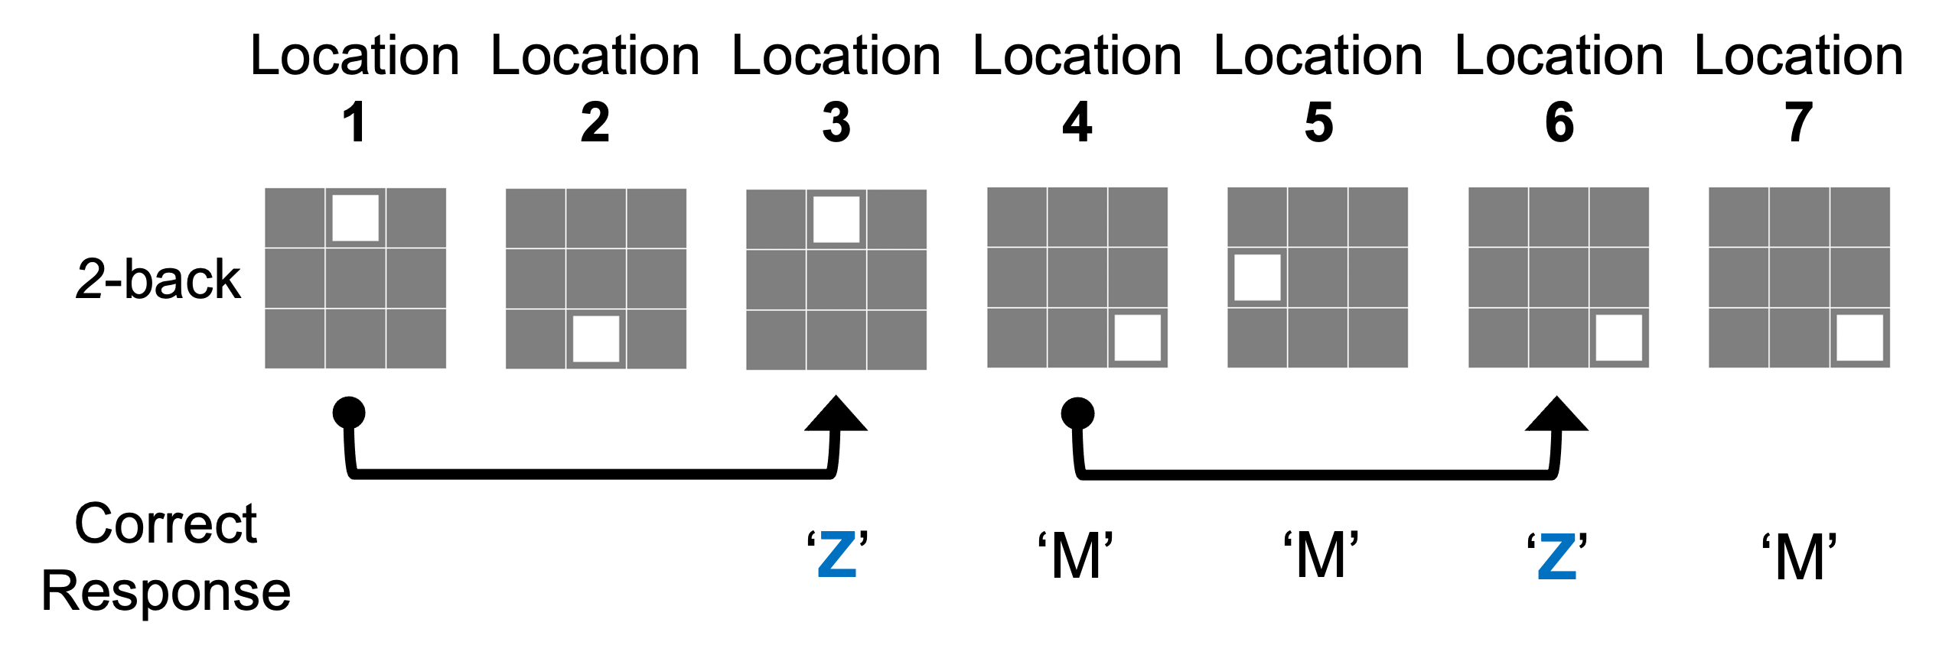
The goal of the second part of the task is to identify if the current location is the same as the location presented one before last (i.e., 2 positions back in the sequence):

- In the above example, there is no response needed for location 1 or 2
- Location 3 is the same as location 1, so a ‘Z’ [for same] response is correct
- Location 7 is the same as location 6, but not location 5, so a ‘M’ response [for different] is correct

If you have any questions, please ask the experimenter now

3-back

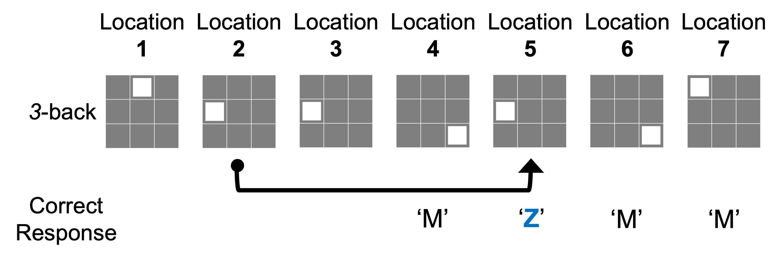
The goal of the third part of the task is to identify if the current location is the same as the location presented 3 positions back in the sequence:

- In the above example, there is no response needed for location 1, 2, or 3
- Location 5 is the same as location 2, so a ‘Z’ [for same] response is correct

If you have any questions, please ask the experimenter now

